6.1

libname orion "C:\Users\Admin\Desktop\SAS\P1 DATA & PROG\P1 DATA";

**DATA** WORK.SUBSET1;

SET ORION.SALES;

WHERE COUNTRY='AU' AND

JOB_TITLE CONTAINS 'Rep';

**RUN**;

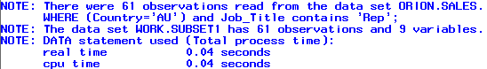

**PROC** **PRINT** DATA=WORK.SUBSET1 NOOBS;

**RUN**;



**DATA** US;

SET ORION.SALES;

WHERE COUNTRY='US';

**RUN**;

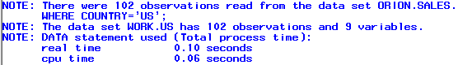

**DATA** WORK.SUBSET1;

SET ORION.SALES;

WHERE COUNTRY='AU' AND

JOB_TITLE CONTAINS 'Rep' AND

HIRE_DATE<**'01jan2000'd**;

**RUN**;

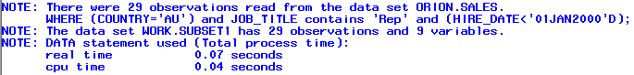

**DATA** WORK.SUBSET1;

SET ORION.SALES;

WHERE COUNTRY='AU' AND

JOB_TITLE CONTAINS 'Rep' AND

HIRE_DATE<**'01jan2000'd**;

bonus=salary\***10**;

**RUN**;

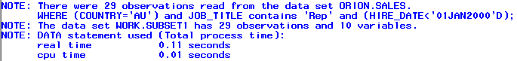

**PROC** **PRINT** DATA=WORK.SUBSET1 NOOBS;

VAR FIRST_NAME LAST_NAME SALARY

JOB_TITLE BONUS HIRE_DATE;

FORMAT HIRE_DATE DATE9.;

**RUN**;



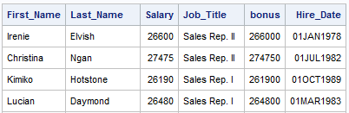

6.2 CUSTOMIZING A SAS DATA SET

**DATA** WORK.SUBSET1;

SET ORION.SALES;

WHERE COUNTRY='AU' AND

JOB_TITLE CONTAINS 'Rep';

bonus=salary*.**10**;

DROP EMPLOYEE_ID GENDER COUNTRY

BIRTH_DATE;

**RUN**;

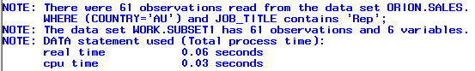

**PROC** **PRINT** DATA=WORK.SUBSET1;

**RUN**;



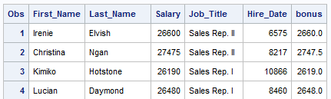

**DATA** WORK.SUBSET1;

SET ORION.SALES;

WHERE COUNTRY='AU' AND

JOB_TITLE CONTAINS 'Rep';

bonus=salary*.**10**;

KEEP FIRST_NAME LAST_NAME SALARY

JOB_TITLE HIRE_DATE BONUS;

**RUN**;



**PROC** **PRINT** DATA=WORK.SUBSET1;

**RUN**;



**DATA** WORK.AUEMPS;

SET ORION.SALES;

WHERE COUNTRY='AU';

BONUS=SALARY\***.10**;

DROP EMPLOYEE_ID GENDER COUNTRY

BIRTH_DATE;

**RUN**;



**DATA** WORK.USEMPS;

SET ORION.SALES;

BONUS=SALARY\***.10**;

WHERE COUNTRY='US' AND BONUS>=**3000**;

**RUN**;

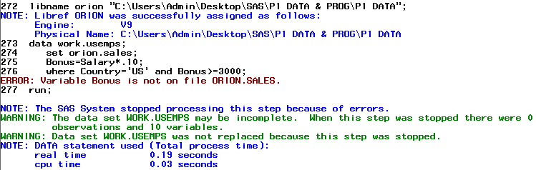

**DATA** WORK.AUEMPS;

SET ORION.SALES;

WHERE COUNTRY='AU';

BONUS=SALARY\***.10**;

IF BONUS>=**3000**;

**RUN**;



**PROC** **PRINT** DATA=WORK.AUEMPS;

VAR FIRST_NAME LAST_NAME SALARY BONUS;

**RUN**;

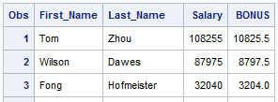

**DATA** WORK.AUEMPS;

SET ORION.SALES;

BONUS=SALARY\***.10**;

IF COUNTRY='AU' AND BONUS>=**3000**;

**RUN**;



**DATA** WORK.SUBSET1;

SET ORION.SALES;

WHERE COUNTRY='AU' AND

JOB_TITLE CONTAINS 'Rep';

BONUS=SALARY\***.10**;

DROP EMPLOYEE_ID GENDER COUNTRY BIRTH_DATE;

**RUN**;

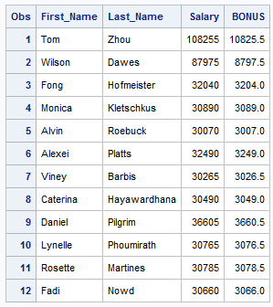

**DATA** WORK.SUBSET1;

SET ORION.SALES;

WHERE COUNTRY='AU' AND

JOB_TITLE CONTAINS 'Rep';

BONUS=SALARY\***.10**;

LABEL JOB_TITLE='Sales Title'

Hire_Date='Date Hired';

DROP EMPLOYEE_ID GENDER COUNTRY BIRTH_DATE;

**RUN**;

**PROC** **CONTENTS** DATA=WORK.SUBSET1;

**RUN**;

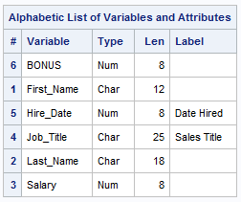

**PROC** **PRINT** DATA=WORK.SUBSET1 LABEL;

**RUN**;

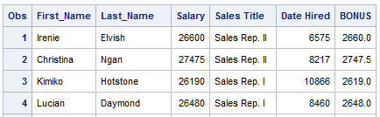

**PROC** **PRINT** DATA=WORK.SUBSET1 SPLIT=' ';

**RUN**;



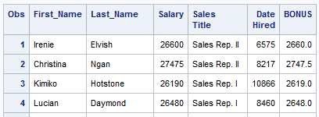

**DATA** WORK.US;

SET ORION.SALES;

WHERE COUNTRY='US';

BONUS=SALARY\***.10**;

LABEL JOB_TITLE='Sales Title';

DROP EMPLOYEE_ID GENDER COUNTRY BIRTH_DATE;

**RUN**;

**PROC** **PRINT** DATA=WORK.US LABEL;

LABEL JOB_TITLE='Title';

**RUN**;

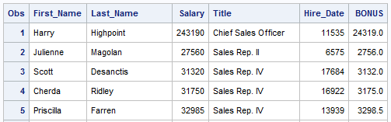

**DATA** WORK.SUBSET1;

SET ORION.SALES;

WHERE COUNTRY='AU' AND

JOB_TITLE CONTAINS 'Rep';

BONUS=SALARY\***.10**;

LABEL JOB_TITLE='Sales Title'

Hire_Date='Date Hired';

FORMAT SALARY COMMAX8. BONUS COMMAX8.2

HIRE_DATE ddmmyy10.;

DROP EMPLOYEE_ID GENDER COUNTRY BIRTH_DATE;

**RUN**;

**PROC** **CONTENTS** DATA=WORK.SUBSET1;

**RUN**;

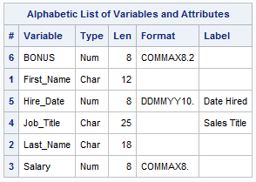

**PROC** **PRINT** DATA=WORK.SUBSET1 LABEL;

**RUN**;

